**Lab Task 8**

**Numerical Computing Lab(105127)**

**Ali Afzal(63961)**

Q1:

Code 1:

from numpy import mat

co = [[25,5,1],[64,8,1],[144,12,1]]

ans = [106.8,177.2,279.2]

aug = mat([[25,5,1,106.8],[64,8,1,177.2],[144,12,1,279.2]])

aug[1,:] = aug[1,:]-aug[0,:]*aug[1,0]/aug[0,0]

aug[2,:] = aug[2,:]-aug[0,:]*aug[2,0]/aug[0,0]

aug[2,:] = aug[2,:]-aug[1,:]*aug[2,1]/aug[1,1]

z = aug[2,3]/aug[2,2]

y = (aug[1,3]-(aug[1,2]*z)) / aug[1,1]

x = (aug[0,3]-aug[0,1]*y - aug[0,2]*z)/aug[0,0]

print('a1: ')

print(x)

print('a2: ')

print(y)

print('a3: ')

print(z)

print(aug)

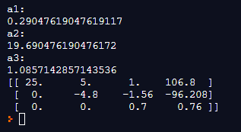

Code 2:

from numpy import mat

def f(a1,a2,a3,t):

return (a1*t*t)+(a2*t)+(a3)

co = [[25,5,1],[64,8,1],[144,12,1]]

ans = [106.8,177.2,279.2]

aug = mat([[25,5,1,106.8],[64,8,1,177.2],[144,12,1,279.2]])

aug[1,:] = aug[1,:]-aug[0,:]*aug[1,0]/aug[0,0]

aug[2,:] = aug[2,:]-aug[0,:]*aug[2,0]/aug[0,0]

aug[2,:] = aug[2,:]-aug[1,:]*aug[2,1]/aug[1,1]

z = aug[2,3]/aug[2,2]

y = (aug[1,3]-(aug[1,2]*z)) / aug[1,1]

x = (aug[0,3]-aug[0,1]*y - aug[0,2]*z)/aug[0,0]

print("Velocity at 6 ",f(x,y,z,6))

print("Velocity at 7.5 ",f(x,y,z,7.5))

print("Velocity at 9 ",f(x,y,z,9))

print("Velocity at 11 ",f(x,y,z,11))

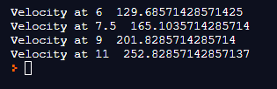

Q2:

|  |  |  |
| --- | --- | --- |
| S# | Functions | Root |
| 1 | 83x+11y-4z=95  7x+52y+13z=104  3x+8y+29z=71 | x=1.0616  y=1.3529  z=2.0 |
| 2 | 8x-3y+2z=45  4x+11y-z=71  6x+3y+12z=35 | x=7.4812  y=3.6833  z=-1.9 |
| 3 | -3x+2y-6z=6  5x+7y-5z=6  x+4y-2z=8 | x=-2.4333  y=3.85  z=1.5 |